*Florida International University*

*School of Computing and Information Sciences*

Software Engineering Focus

Interactive Paint

User Story ID <319>

**Name:**

Daniel Mederos

**Team Member(s):**

Jim Louro

**Project:**

Interactive Paint

**Product Owner(s)**:

Francisco Ortega

**Mentor(s)**:

**Instructor**: Masoud Sadjadi

**User Story Name:** Create a Brush

* Description: **As a** User **I would like** to create free draw **so that** it can show up in the GUI Canvas

Acceptance Criteria

* The free draw should be able to be created on the GUI canvas (Devices we currently own)
* The dropdown menu with the brush draw button should be presented to the user
* The brush button in the dropdown menu when clicked should draw when input is dragged across the GUI Canvas

**Use Case** Create a brush in the GUI Canvas

|  |  |  |
| --- | --- | --- |
| #**344** Implement brush | | |
| ***Description*** | When the user clicks on the line button, the user should then be able to free draw when he/she clicks on the GUI canvas | |
| ***Actor*** | User of Interactive Paint | |
| ***Precondition*** | GUI must be running | |
| ***Flow of Events*** | **User** | **System** |
| **1.** | User clicks on Brush button | A dropdown menu appears and the brush button appears |
| **2.** | User clicks on line button | The mouse pointer is now active with the brush function |
| **3.** | User clicks on the GUI Canvas | A dot appears on canvas when canvas receives a click or input and when moved it forms a 2d non linear shape that ends when the click or input stops |

**Use Case Diagram**

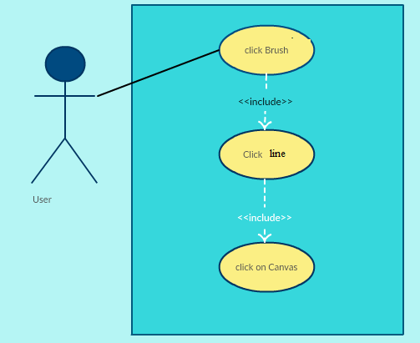

**Sequence Diagram**

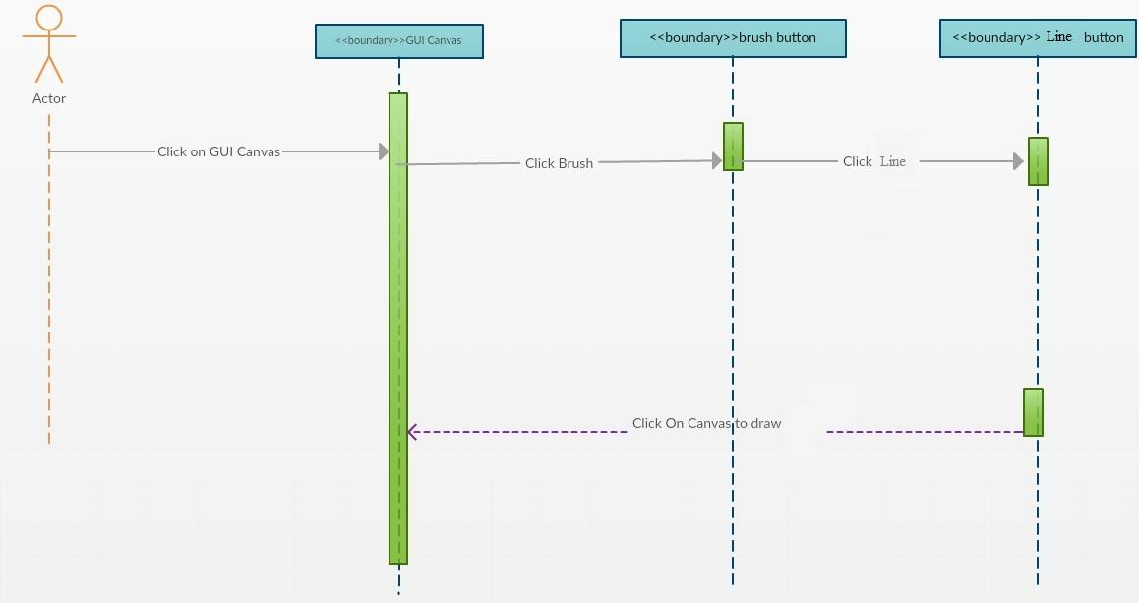

**Class Diagram**

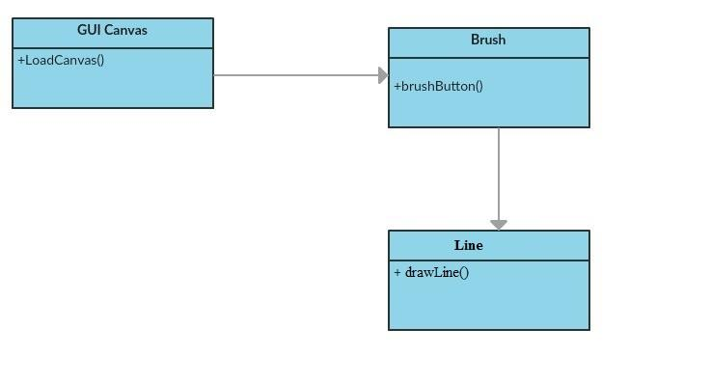

**Integration Test**

**Testing**

**Description:**

* Test the Line button and lets the user draw a Line on the GUI canvas

**Work Log:**

**Unit Test**

**Test Case 1 (sunny)**

***Purpose:*** to test that the line button appears when user clicks on brush button

* Precondition The user must have QT plugin for visual studio and must run the program
* Input: User clicks on brush button which then a drop down menu appears
* Expected Result: line button appears on GUI Canvas from a drop down menu
* Actual Result: Actual result was found to be the expected result.
* Status: **PASSED**

**Test Case 2 (sunny)**

***Purpose:*** to test that the line button properly lets the user draw a line on the GUI Canvas

* Precondition The user must have QT plugin for visual studio and must run the program
* Input: User clicks on brush button which then a drop down menu appears and must click line
* Expected Result: line appears on GUI Canvas when dragged across canvas
* Actual Result: Actual result was found to be the expected result.
* Status: **PASSED**

**Test Case 3 (rainy)**

***Purpose:*** to test that the line button appears when user clicks on brush button

* Precondition The user must have QT plugin for visual studio and must run the program
* Input: User clicks on brush button which then a drop down menu appears
* Expected Result: line button appears on GUI Canvas from a drop down menu
* Actual Result: Actual result was found to be the expected result.
* Status: **PASSED**

